Costing & Procurement

Procurement List
Equipment | Specification | Quantity
Router | Gigabit Router | 1
Switch | Switch D-Link 24-Port Gigabit DGS-1024D | 1
Wireless Access Point | Wi-Fi 6 Access Point | 1
Workstation | Intel Core i5, 8GB RAM, 256GB SSD | 1
Server | Entry-Level Server | 1
Monitor | 24-inch LED Display | 1
Laser Printer | Network Printer | 1
UPS | 1000VA UPS | 2
Cat5e UTP Cable | UTP Cable | 200m
RJ45 Connector | Cat5e Compatible | 50
Patch Panel | 24-Port | 1
Network Rack | 12U Rack Cabinet | 1

Costing:
Router
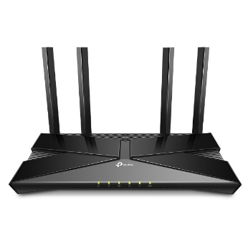Router Wireless AC1200 MU-MIMO Wi-Fi Gigabit Router DIR-842 | Specification  Wireless AC1200 MU-MIMO  Wi-Fi Gigabit Router  DIR-842  Dual-band Wireless AC1200  (867 Mbps on 5 GHz + 300 Mbps on 2.4  GHz)  - 802.11ac with MU-MIMO  - Gigabit WAN and 4 x Gigabit LAN
Manufacturer | MU-MIMO
Model Name | DIR-822
Quantity | 1
Unit Price | RM 200.00
source | www.shopee.com.my
Switch

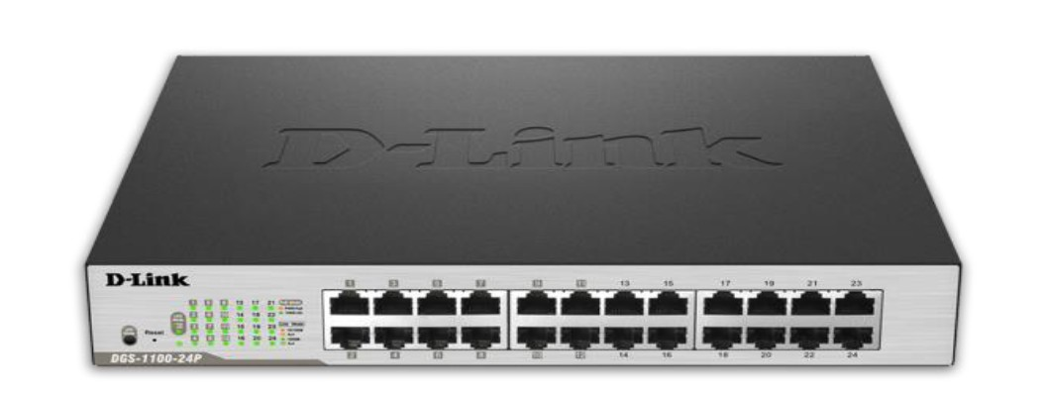

Switch D-Link 24-Port Gigabit DGS-1024D
Specification | - Switching Capacity: 48 Gbps  - Maximum Power Consumption: 13.3 W  - Max. Packet Forwarding Rate, 35.71 Mpps  - Auto MDI/MDIX
Manufacturer | D-Link
Model Name | DGS-1024D
Quantity | 1
Unit Price | RM 483.00
source | www.shopee.com.my

Wireless Access Point
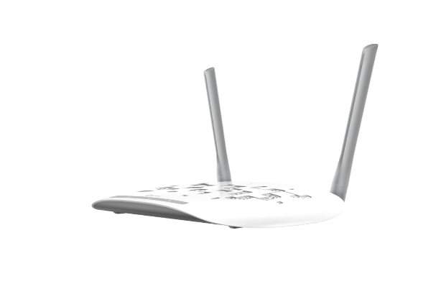 Access Point TP-Link Access Point Wireless N300Mbps
Specification | -Frequency, 2.4-2.4835GHz  - Power Consumption, 5.8W  - Interface, One 10/100M  Ethernet Port(RJ45)  Support Passive PoE  - Antenna Type, 3*5dBi  Detachable Omni Directional (RP-SMA
Manufacturer | TP-Link
Model Name | TL-WA901ND
Quantity | 1
Unit Price | 99.00
source | https://server2u.com/

Workstation
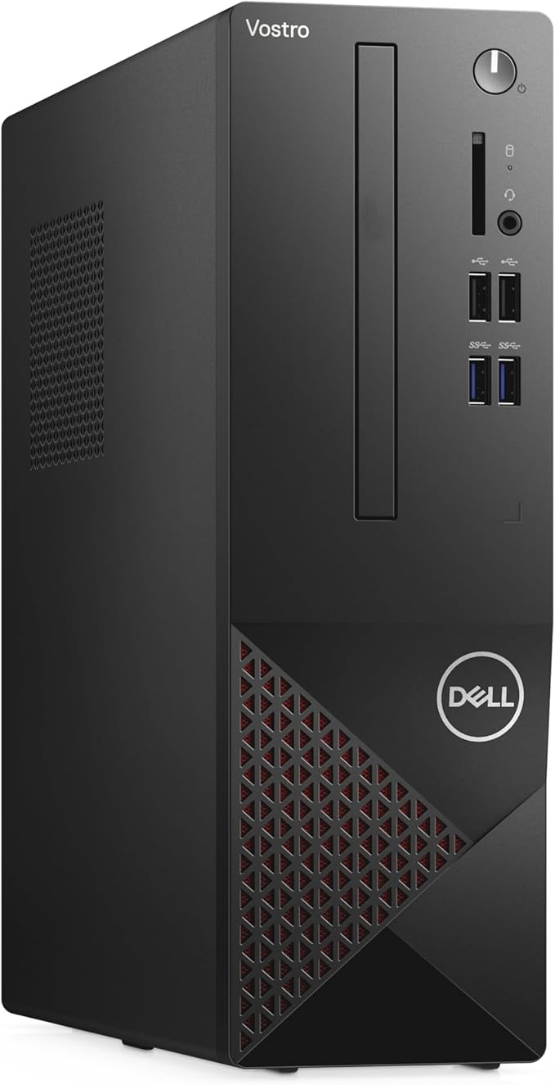
Dell Vostro 3681 Desktop PC/Intel 10th Gen Hexa-Core i5-10400/8GB RAM/256GB SSD

Specification
  - Intel® Core™ i5-10400 Hexa-Core Processor
  - 8GB DDR4 2666 MHz DDR4 UDIMM non-ECC Memory
  - 256GB M.2 PCIe NVMe Class 35 Solid State Drive

Manufacturer | Dell
Model Name | Dell Vostro 3681
Quantity | 1
Unit Price | RM 1560.00
source | www.shopee.com.my
Server
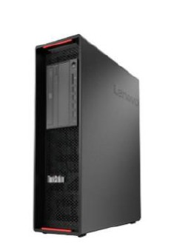
Web Server Think Station P720

Specification

-Tower Intel Xeon E224G
-8 GB RDRIMM DDR4 2933MHz ECC
-Memory ITB 7.2K Entry SATA
- Ability to access vast amounts of
data quickly over the network.

Manufacturer | Lenovo
Model Name | Think Station P720
Quantity | 1
Unit Price | RM 7559.00
source | www.lenovo.com.my

Monitor
Dell 24 Monitor - SE2426H
Specification
Standard Refresh Rate 144 Hz
Cable Type Included
Power Cable
1 x HDMI Cable - 1.80 m

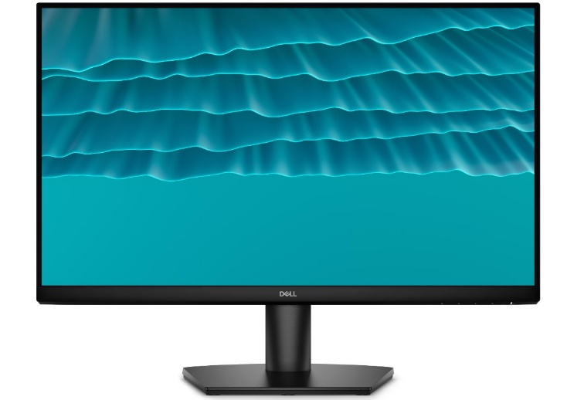
Manufacturer | Dell
Model Name | SE2426H
Quantity | 1
Unit Price | 400
source | www.dell.com.my

5 UTP Cable Construction
T568B Color Code
pin | Wire Color
1 | White/Orange
2 | Orange
3 | White/Green
4 | Blue
5 | White/Blue
6 | Green
7 | White/Brown
8 | Brown

Straight-Through Cable (PC-to-SWITCH)
End A (T568B) | End B (T568B)
White/Orange | White/Orange
Orange | Orange
White/Green | White/Green
Blue | Blue
White/Blue | White/Blue
Green | Green
White/Brown | White/Brown
Brown | Brown

Crossover Cable (Switch-to-Switch)
End A (T568B) | End B
White/Orange | White/Green
Orange | Green
White/Green | White/Orange
Blue | Blue
White/Blue | White/Blue
Green | Orange
White/Brown | White/Brown
Brown | Brown

